Southern California Geographic Area Coordination Center







***Southern California Geographic Area Coordniation Center (OSCC)***

is located at the CALFIRE Southern Region in Riverside, California.

Physical Address. OSCC

2524 Mulberry Street

Riverside, CA 92501

1-800-XXL-FIRE (995-3473)

Federal Duty Officer 951-276-6725

State Duty Officer 951-320-6197

General Fax 951-782-4900

Website: <http://gacc.nifc.gov/oscc/>

***Southern California Geographic Area Coordination Center***

**Table of Contents**

Page #

***Introduction***

Mission Statement…………………………………………………………………………………………………. 3-5 Brief Profile

Working Atmosphere

Appropriate Attire

During your Stay

OSCC Staff

Lodging, Meals and Transportation

***Personal Items****………………………………………………………………….…………………………………………..* 5-7

OSCC Security

Timekeeping

Lunch and Breaks

Smoking Policy

Restrooms

Handicap Accessible

Contact with Inmate Crews

Sick Leave/On-the-Job Injuries

Upon Completing Your Stay

Performance Evaluations/Task Books

***OSCC Emergency Procedures***…………………………………………*………………………………………….* 7-8

***OSCC Functional Areas and Position Descriptions****………………………………..……….………* 8-9

Functional Areas

Position Descriptions

***OSCC General Office Procedures****……………………………………………………….………….……….….* 9-11

Office Procedures

POD Books

Telephone Usage and Procedures

Computers / Internet

Software Applications/ Websites

***Demobilization, Reassignment and R&R*** *…………………..………………………………..………….* 11-12

**Appendix A *– Organization Chart/***

***Geographical Area Map*** *……………………………….…………….……………………..* 13-15

**Appendix B *– South Ops Maps****……………………………………………………………..……………….…..* 16-24

**Appendix C *– Agency Designators/***

***ROSS CC Designators for OSCC***………………….………………………………..…… 25-26

**Appendix D *– Local Amenities***…………………………………………………………………………………. 27-32

**Appendix E *– OSCC Detailer Survey***………………..….…………………………………………………… 33

***Introduction***

***Southern California Geographic Area Coordination Center Mission Statement***

The principal mission of the Southern California Geographic Area Coordination Center (OSCC or also known as “South Ops”) is the cost effective and timely coordination of land management agency emergency response to wildland fire and all risk incidents. This is accomplished through planning, situation monitoring and expediting resouce moblization between the California Department of Forestry and Fire Protection (CALFIRE), USDA Forest Service (USFS), National Park Service (NPS), Bureau of Indian Affairs (BIA), Fish and Wildlife Service (FWS), National Weather Service (NWS), Federal Emergency Management Agency (FEMA), California Office of Emergency Services (CalOES), Contract Counties and Local Government.

The mission of OSCC includes providing quality coordination and aircraft dispatch services in a professional, efficient manner. Employees assigned to OSCC shall fulfill this mission in a manner consistent with the following values and expectations.

1. **Professionalism:** The degree of professionalism we exhibit is a reflection of the pride we have in ourselves and our Coordination Center. Professionalism means more than just being highly skilled or doing your job well. It’s an attitude, which is reflected in our conduct, appearance and relationships with others.
2. **Teamwork:** Teamwork requires that we support and rely upon one another in an atmosphere of shared responsibility. It is essential to achieving our mission. Honesty, communication, trust, and a sense of fairness are essential to foster teamwork.
3. **Accountability:** Accepting responsibility and being accountable for our actions, is a mark of professionalism. The duties performed by each of us contribute to the overall achievement of the OSCC mission, and we each must be accountable for our role in this effort.
4. **Productivity:** Productivity is the amount of work performed. Being a productive employee means giving our best effort to every task, every day. Because much of the work we perform cannot be measured in the traditional sense, productivity must be measured against our personal capabilities.
5. **Communication:** The freedom to express one’s thoughts and ideas is essential to creating a positive work environment. Each one of us has the responsibility to communicate constructive comments and criticisms for improvement of the operation as well as the right to expect that our comments will be received and considered in a fair and non-judgmental manner.
6. **Initiative:** Personal initiative means being proactive in identifying tasks or issues that need action and in taking the necessary steps to complete them, without being directed. We must each take the initiative to solve problems, rather than ignoring them, hoping they will go away.
7. **Respect:** Respect is the foundation for developing positive interpersonal relationships and creating a healthy work environment. Every employee has the right to be treated fairly and equitably in a work environment free from any form of harassment or discrimination. Anything less is unacceptable, since it is not only a violation of established policy, it is just simply wrong.

***Brief Profile of OSCC***

Initially established in 1972, the Coordination Center, now known as OSCC, provides logistical support and intelligence for wildfires in Southern California. Planning, situation monitoring needs projections, and resource order processing are all handled from the center's Riverside location. OSCC also provides logistical support for other non-fire disasters, including hurricanes, earthquakes, and floods.

How does it work? When local dispatch offices have exceeded their internal capability to fill resource requests locally, those requests are placed up to the Geographical Area Coordination Center (GACC). There are eleven (10) GACCs covering the United States (see Appendix A, page 15). OSCC is the Geographical Area for Southern California.

The OSCC is an interagency organization that handles resource distribution for all-risk management incidents. Personnel handle all requests for aircraft, crews, overhead, and equipment. They process dispatch records, contact unit dispatchers for resources to fill orders, and handle all incoming telephone and fax communications. An Expanded Dispatch operation processes extended attack or long-term incidents. Based on the “closest forces” concept, OSCC mobilizes the closest available qualified resource regardless of agency affiliation. In addition to coordinating resources between state and federal units, OSCC also hires federal Type 3 Call-When-Needed (CWN) helicopters and CWN light, fixed-wing aircraft, incident base services, and miscellaneous privately-owned equipment.

***Working Atmosphere***

OSCC has a zero tolerance policy for harassment of any kind. All employees, cooperators, contractors and volunteers who participate in wildland fire operations have the responsibility to treat one another with respect. Every employee at OSCC takes personal responsibility for creating and ensuring a healthy and safe work environment.

Every individual assigned to OSCC has a responsibility to report harassment or inappropriate behavior, and take positive action to mitigate the effects. Promptly notify the Expanded Supervisor, Coordinator, or a Duty Officer should any such situation develop.

OSCC takes pride in maintaining a professional and service-oriented working atmosphere while still allowing for some informality. We want you to have fun working here, but we also expect you to use common sense and do your assigned job to the best of your ability. If you have questions, please do not hesitate to ask for help.

***Appropriate Attire***

In order to maintain a professional atmosphere at OSCC we request that visitors and detailers wear casual, office-style apparel if they are not an agency employee. This includes jeans or slacks with closed toe, closed heel shoes for safety. If you are an agency employee, uniforms are preferred.

With a large group working in a relatively small working space, it is difficult to keep the temperatures comfortable for everyone. We recommend that you bring a sweater or jacket to ensure your comfort.

***During Your Stay***

If you have any questions or concerns, please direct them to the Expanded Supervisor, or a Coordinator. If your question/concerns cannot be met at this level, please contact a Federal or State Duty Officer.

***OSCC Staff***

OSCC is staffed with 5 Forest Service Logistics Coordinators, 1 Forest Service Aircraft Coordinator, a Forest Service Mobilization Coordinator, 4 State Battalion Chiefs, and 4 State Communication Operators. An organization chart is located in Appendix A.

***Lodging, Meal and Transportation***

If you need lodging reservations made for you, please inform a Coordinator. For employees who do not have a Government-issued travel card, lodging can be reserved and paid for on a BPA or through CALFIRE depending on the financially responsible agency. If lodging is being paid for you, you are responsible for personal telephone calls, movies and miscellaneous expenses. A list of local hotels is provided in Appendix C.

Most people pay for their own meals via their per diem allowance. If you have any special needs please contact the Duty Officer or a Coordinator.

Authorization for rental cars will be stated on your Resource Order. To minimize rental vehicle costs, if you can car pool to and from your hotel with someone else assigned to the same shift, it is strongly advised.

Below are the 2014/2015 Riverside area per diem rates.

|  |  |  |  |  |  |  |  |  |  |  |  |  |  |  |
| --- | --- | --- | --- | --- | --- | --- | --- | --- | --- | --- | --- | --- | --- | --- |
| The following rates apply for **92501** | | | | | | | | | | | | | | |
| Primary Destination | County | **Max lodging by Month (excluding taxes)** | | | | | | | | | | | | **Meals & Inc. Exp.** |
| Palm Springs | Riverside | 2014 | | | 2015 | | | | | | | | |
| OCT | NOV | DEC | JAN | FEB | MAR | APR | MAY | JUN | JUL | AUG | SEP |
| 110 | 110 | 110 | 128 | 128 | 128 | 128 | 128 | 90 | 90 | 90 | 90 | **71** |

***Meals and Incident Expense Breakdown***

|  |  |  |  |  |
| --- | --- | --- | --- | --- |
| Total | Continental  Breakfast/  Breakfast | Lunch | Dinner | IE |
| $71 | $12 | $18 | $36 | $5 |

***Personal Items***

***OSCC Security***

Access to the OSCC compound can be accessed through the northeast gate on Holding Ave. Press the “call” button on the gate panel and wait for the gate to open. If the Dispatch Office is not staffed there is no one to open the gate for you. If the gate does not open within 2 minutes, then call the 24-hour number.

**OSCC 24 hour number Federal 951-276-6725; State 951-320-6197**

Parking for OSCC Dispatch is in the West parking area near Mulberry Street. For staff safety, please do not drive over 5 miles an hour while on the OSCC compound.

***Timekeeping***

You are responsible for keeping track of your own time. Time should be recorded to the nearest quarter hour. The OF-288 (Emergency Firefighter Time Report) is available electronically. Please contact a USFS Coordinator should you require the hard copy version. It is recommended that you complete the OF-288 daily, and have the form signed off by the Functional area Supervisor at the end of each column (Block 12) when your assignment is over. The white copy of a paper version of the OF-288 or a printed copy of the electronic OF-288 is to be left at OSCC. The other copies are taken with you back to your home unit. Any questions please ask a Coordinator or the Duty Officer.

***Lunch and Breaks***

Please notify your functional area Supervisor (for your assigned expanded group) or the Duty Officer when you take a break or lunch to ensure adequate staffing. A meal period of 30 minutes must be taken for each work shift. If an extended break is needed, contact your Expanded Supervisor, or the Duty Officer.

The OSCC kitchen has a refrigerator, a freezer, two microwaves, and a toaster. If you choose to bring your lunch into the office, please eat in the break room. When storing your food items, label them before placing them in the kitchen or refrigerator with your name and the current date. If food items are not labeled, they could be considered community food. Also remember to take your items with you on your scheduled days off or at the end of your assignment, to alleviate storage space issues for those still on duty. ***Please wash your dishes, dry them and put them away. Remember to clean up after yourself.***

***Smoking Policy***

All buildings are smoke free; there is a designated area for smoking outside each building.

***Restrooms***

Restrooms are located on the west side of the dispatch building.

***Handicapped Accessible***

The OSCC compound is handicapped accessible. If you have any issues or special needs, please contact any staff member for assistance.

***Contact with Inmate Crews***

Fire crews from the California Department of Corrections are often assigned to the OSCC compound to do general maintenance projects. Please do not communicate in any way, and avoid contact with inmates to minimize any potential problems.

***Sick Leave/ On-the-Job Injuries***

When you first arrive you will be ask to fill out an emergency contact card. If you become ill while on duty, notify the Expanded Supervisor or the Duty Officer immediately. If you cannot come in for your scheduled shift, please call the Duty Officer before your shift starts so arrangements can be made to cover your shift. If you feel your illness or injury will prevent you from staying on assignment, let the Duty Officer know so demobilization arrangements can be made.

If you are injured while on duty, please see the Duty Officer as soon as possible to have a CA-1/2 *Notification of Injury* form completed. If further medical attention is needed a CA-16 *Medical Authorization* form must be filled out prior to visiting a doctor or hospital.

***Performance Evaluations/Task Books***

Performance evaluations will be completed for every trainee assigned to OSCC and anyone who asks for one. If you are working on completing a Task Book, please let the Mobilization Coordinator know upon your arrival. Only qualified OSCC employees can sign off items you successfully complete in your Task Book. The Task Book must be properly initiated from your home unit. If you did not bring your Task Book with you, call your home unit and have them mail it to you.

ATTN: “YOUR” Name

Southern Operations Dispatch

2524 Mulberry Street

Riverside, CA 92501

***Upon Completing Your Stay***

Upon completing your assignment at OSCC, PLEASE remember to complete the *OSCC Detailer Check- Out List* found in Appendix E. This form can be obtained from the Expanded Dispatch rooms, or from the Expanded Supervisor or Duty Officer. We welcome comments or ideas on how we can improve our center.

***OSCC Emergency Procedures***

***Fire Evacuation Procedures***

The OSCC Dispatch building is equiped with automatic fire alarms. The building exits are posted thoughout the building. Make yourself aware of these exits when you arrive and as you learn your way around. When an alarm sounds, everyone will follow these procedures.

* Evacuate the building by walking to the nearest exit. Close office doors behind you. Employees and visitors with disabilities should be assisted by any available personnel.
* Proceed to designated assembly areas: in the front parking lot at the flag pole.
* Supervisors should ensure that all floor personnel are accounted for.
* Return to building only after “all Clear” has been given by the Fire Department.

***Procedures in the Event of a Bomb Threat by Telephone***

* Behave in a calm and courteous manner.
* Do not attempt to transfer the call or put the caller on hold.
* Keep caller on the line as long as possible and notify a supervisor or other personnel by motion, signal or note.
* Use Bomb Threat Check List as a guide for gaining information about the caller. This form is posted near each telephone thoughtout OSCC. It is important to fill out the form while the voice and message are still fresh in your mind. This data is crucial for getting informtion to the right people at the right time and determining safe evacuation of the premises.
* In the event of a bomb threat, total evacuation must commence immediately with direction from the Duty Officer. Evacuation will be to the designated area, usually the futherest parking area from the immediate building.
* Prior to evacuation, employees will make a quick check of their areas for anything out of place or additional packages in the area such as extra brief cases, boxes etc. The quick check is requested because employees know their work area and surroundings better than anyone else.
* **DO NOT USE** 
  + **Cell phones for anything.**
  + **The intercom**
  + **Any electric devices**

***Physical Attacks and Assaults***

Local Law Enforcemnt (9-1-1) should be notified without delay for a physical attack or assault of an individual. No matter what other action may have been taken by Law Enforcement or the legal process to correct the violent individual(s), management should make a written record of the attack and the response.

***OSCC Functional Areas and Position Discriptions***

***Functional Areas***

OSCC Expanded is separated into five functional areas:

**Equipment/Supplies**: Coordinates the moblization of telecommunications equipment, incident base services, GIS trailers, clerical support trailers, and refrigerated trailers, rolling stock – engines, water tenders, and dozers. Also, supplies such as cache or NFES items and mobile cache vans.

**Crews:** Coordinates moblization of federal, state, and contract crews.

**Overhead:** Coordinates moblization of single resouce overhead positions, speciality teams including: Area Command Teams; Type 1 and Type 2 Incident Management and Incident Command Teams; Burned Area Rehabiliation Teams, etc.

**Aircraft:** Coordinates airtankers, lead planes, aerial supervison modules, helicopters, Modular Airborne Fire Fighting Systems (MAFFS), and frequencies. Manages Temporary Flight Restrictions (TFRs) and airspace deconfliction with the military.

**Predictive Services:** Collects, consolidates and disseminates information to cooperating agencies, fire managers and the public; responds to special requests for information, prepares daily, weekly, monthly and annual reports/assessments and assists with briefings during periods of high activity.

***Position Descriptions for OSCC Staff***

**Communication Operator (State):** Responsible for dispatching aircraft, and emergency resources and for completing and disseminating reports and information regarding resource availability. Each Communication Operator is typically assigned to a specific functional area during expanded operations and can assist you with your daily tasks and answer many of the questions you may have.

**Logistics Coordinator (Federal)/Battalion Chief (State):** OSCC staff members are typically assigned to a specific functional area. Each member is capable of functioning in most areas, but has a specific area of experience in which they are most knowledgeable. There will be at least one regular staff member assigned to each functional area. The OSCC staff can assist you with daily tasks and answer most questions.

**Duty Officer (Federal and State)**: The Duty Officer is the Point of Contact between functional areas and the management staff. The Duty Officer makes moblization decisions with appropriate intel, and drawdown information. The Duty Officer ensures there is approprate staffing and coverage, and completes timesheets and performance evaluations for visitors and detailers.

**Aviation Coordinator (Federal):** The Aviation Coordinator specializes in aviation coordination, mobilization and demobilization; and is responsible at OSCC for providng efficient, cost-effective aviation services to the field. The Aviation Coordinator processes all aircraft administrative paperwork, including billing and scheduling of administrative flights, and is assigned to the functional area of support aircaft when on duty.

**Division Chief (State):** The Division Chief is the CALFIRE regional liaison who interfaces with other agencies and private cooperators to keep them informed of dispatching operations and procedures and to coordinate resouces with other agencies for responding to incidents of mutual concern. Coordination includes utilization of aircraft, ground resouces, and hired equipment for CALFIRE region wide to maintain an effective initial attack force and control incidents. The Division Chief is responsiabliie for planning, implementing, supervising, and training in the use of the Regional Command and Control System.

**Mobilization Coordinator (Federal):** The Mobilization Coordinator is primarily responsible for ensuring the operations of the Coordination Center provide efficient and cost-effective service to the field. The duties include coordinating mobilization of all requested resouces, making OSCC staff shift assignments and schedules, reviewing dispatcher work for accuracy and timeliness, and providing input on where to place orders for resouces. The Mobilization Coordinator is responsiable for the welfare of OSCC personnel and resolves problems that are beyond resolution at the functional area level.

**Center Manager & Deputy GACC Manager (Federal):** The Center Manager is responsible for the overall management of OSCC and provides multi-agency direction for OSCC activities. The Center Manager interacts with multi-agency managers and directors, military and political officials, incident commanders, area commanders, and others outside of OSCC. The Deputy GACC Mgr. primary duty is to provide direction and advise to the Mobilization Coordinator.

***OSCC General Office Procedures***

* Be Professional.
* Receive assignment from the Mobilization Coordinator.
* Review the shift brief from the person you are relieving and verbally debrief your replacement.
* Review all resouce orders, take note of the status of pending requests.
* Review all database reports/files related to your functional area.
* Perform work according to standards and time frames established by the *National Interagency Moblization Guide*, *California Mobilization Guide*, the *Interagency Standards for Fire and Fire Aviation Operations* (Red Book) and *OSCC Operations Guide* and from the Mobilization Coordinator.
* Refer personnel problems and employee suggestions to the Mobilization Coordinator.
* Notify the Functional Area Supervisor or Mobilization Coordinator of changes to personnel schedules which may affect staffing/shifts.
* Keep your desk area clean and orderly for the next shift or day.
* Immediately notify the Functional Area Supervisor or Mobilization Coordinator of any problems relating to improper ordering procedures.
* Refer questions concerning policy or procedures to the Functional Area Supervisor.
* At the end of your shift, review shift notes to ensure complete documentation.
* Verbally brief the person relieveing you and the Functional Area Supervisor on outstanding requests, problems and shift notes.

***POD Books***

You will find the majority of the answers to questions that you might have located in the POD Books on your assigned POD shelf. It is highly advisable to familiarize yourself with the OSCC POD Books.

***Telephone Usage and Procedures***

Always answer “South Ops this is (your name).” When speaking on the phone, be courteous and professional. If someone is rude to you, put them on hold and notify the Functional Area Supervisor or Mobilization Coordinator, who will take the call. You are not expected to communicate with unruly callers.

All phones should to be answered by the second ring. If you cannot answer a question, put the caller on hold and find someone who can help. If you cannot find assistance right away, take the caller’s name and number and call them back with the information requested. Refer all calls to the appropriate desk or take messages, unless you are requested to assist in that functional area.

Do not give out personal home phone numbers to the public.

***Computers***

Upon arrival, each person will be assigned a functional area and computer. If you do not have an agency log in, you will be given one.

Computers on the command and expanded floors are a combination of CALFIRE and Forest Service. At the end of your shift, please restart your computer. Click Start, Shutdown, and select Restart from the drop down menu and click OK. This will refresh the system for the next user and leave it operational for automated security software upgrades.

If you are having computer issues, contact the Functional Area Supervisor or Mobilization Coordinator to notify the appropriate agency computer specialist.

***Internet***

Internet use should be work related and used sparingly to minimize electornic traffic and maximize performance for all users. Never download screensavers or other software to the OSCC computers. Be cautious of computer usage. All documents and e-mails are stored electronically and may be reviewed at any time.

***Software Application/Websites***

The following applications and websites are used commonly at OSCC:

AirNav Microsoft Outlook

WinCAN Microsoft Office

Automated Flight Following ROSS

Defense Internet NOTAM Service

***Demobilization, Reassignment and R&R***

Fire assignments generally last 14 days (excluding travel), although we sometimes have long-term detailers assigned at OSCC. The duration of the assignment is generally agreed upon at the time of dispatch. You may be released from your assignment for a variety of reasons: end of commitment, lack of fire activity, reassignment, or performance-related issues. Please inform the Mobilization Coordinator if you mobilized with a round trip airline ticket.

**Prior to your departure, you should ensure you have done the following:**

* Completed and signed time sheet (OF-288) with the appropriate funding codes.
* Completed and signed Performance Evaluation.
* Completed Task Book as appropriate.
* Returned any items checked out in your name.
* Removed and properly disposed of any perishable food items in the kitchen.
* Completed your demobilization travel with the Overhead Supervisor and entered it into ROSS.
* If your hotel is being paid by the GACC the hotel receipts needs to be left with a Coordinator.

If you are an agency employee and your first day home from a 14-day assignment falls during one of your normal work days, you may be eligible for a paid administrative day(s) off at your home unit.

Information regarding administrative leave can be found in the Interagency Incident Business Management Handbook Chapter 10.

OSCC does NOT issue written requests for administrative leave for departing detailers, so please do not ask.

OSCC makes demobilization flight arrangements at the most cost effective and via the most direct route to your home base. OSCC will not authorize any deviation to your official release and home unit return travel to accommodate personal needs. Any change to your demob travel for personal reasons that results in additional travel costs will be at your expense. This applies whether you are flying or driving. Per Diem will not be allowed while you are in non-pay status.

When OSCC releases personnel excess to needs, an attempt will be made to offer options for reassignment; however, this is not guaranteed. Please remain flexible.

**BLM**

**DOI Logistics coordinator**

**Les Matarazzi**

**Appendix A**

OSCC Organization Charts and GACC Map

Fire and Aviation Management -

Southern Operations Branch

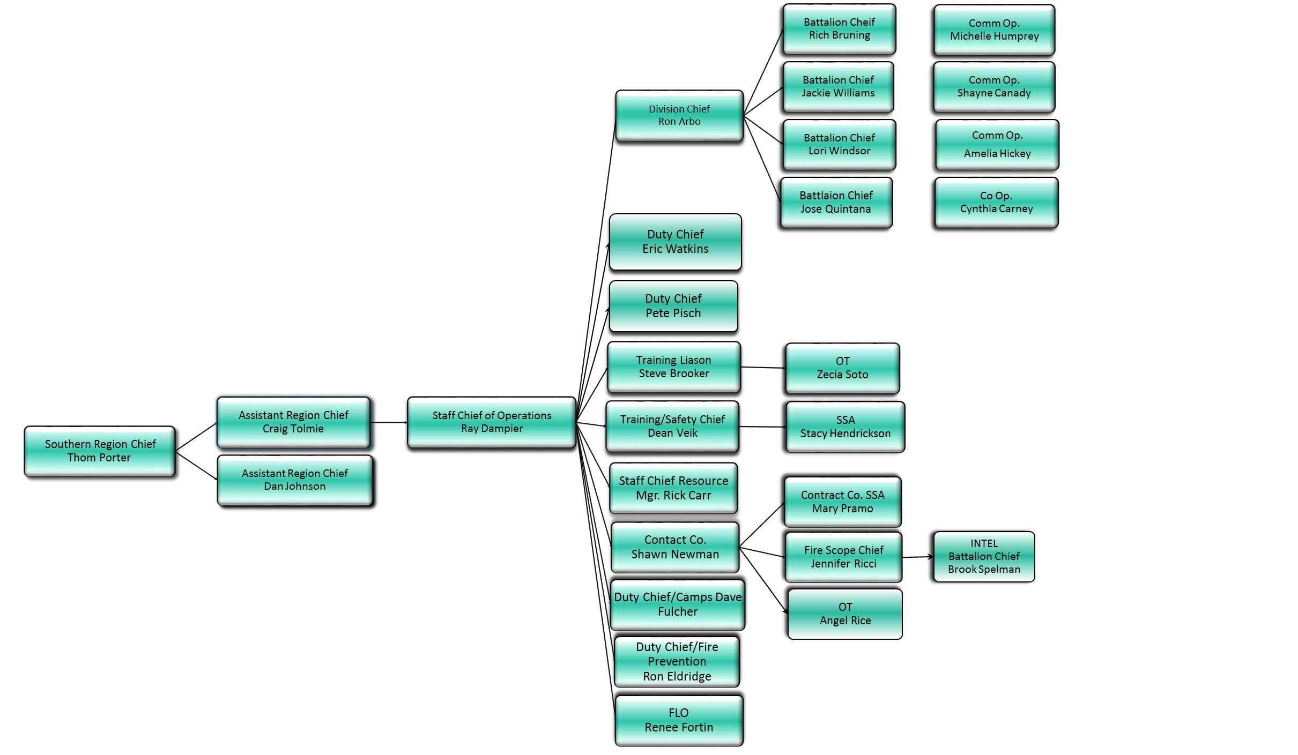

**Appendix A**

OSCC Organization Charts and GACC Map

CALFIRE -

Southern Operations Branch

**Appendix A**

**National Geographic Area Coordination Centers (GACCs)**

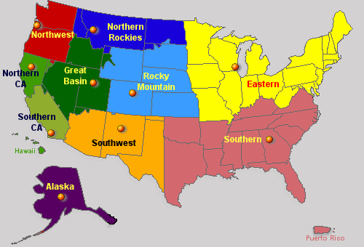

**The 10 Geographic Coordination Centers and the Cities they are located in:**

Alaska Geographic Area Coordination Center; Fairbanks, AK

Northwest Area Coordination Center, Portland, OR

California Northern Operations Area Coordination Center, Redding, CA

California Southern Operations Area Coordination Center, Riverside, CA

Northern Rockies Area Coordination Center, Missoula, MT

Great Basin Area Coordination Center, Salt lake City, UT

Southwest Area Coordination Center, Albuquerque, NM

Rocky Mountain Area Coordination Center, Lakewood, CO

Eastern Area Coordination Center, Fort Snelling, MN

Southern Area Coordination Center, Atlanta, GA

**Appendix B**

Map and Driving Directions from ONT (Ontario Airport) to South Ops

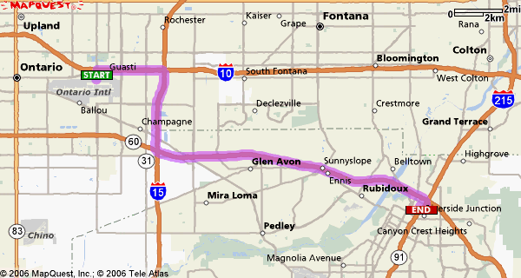

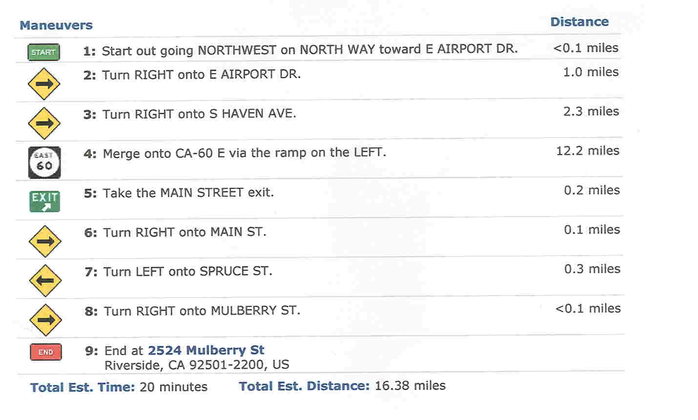

**Appendix B**

**OSCC Compound**

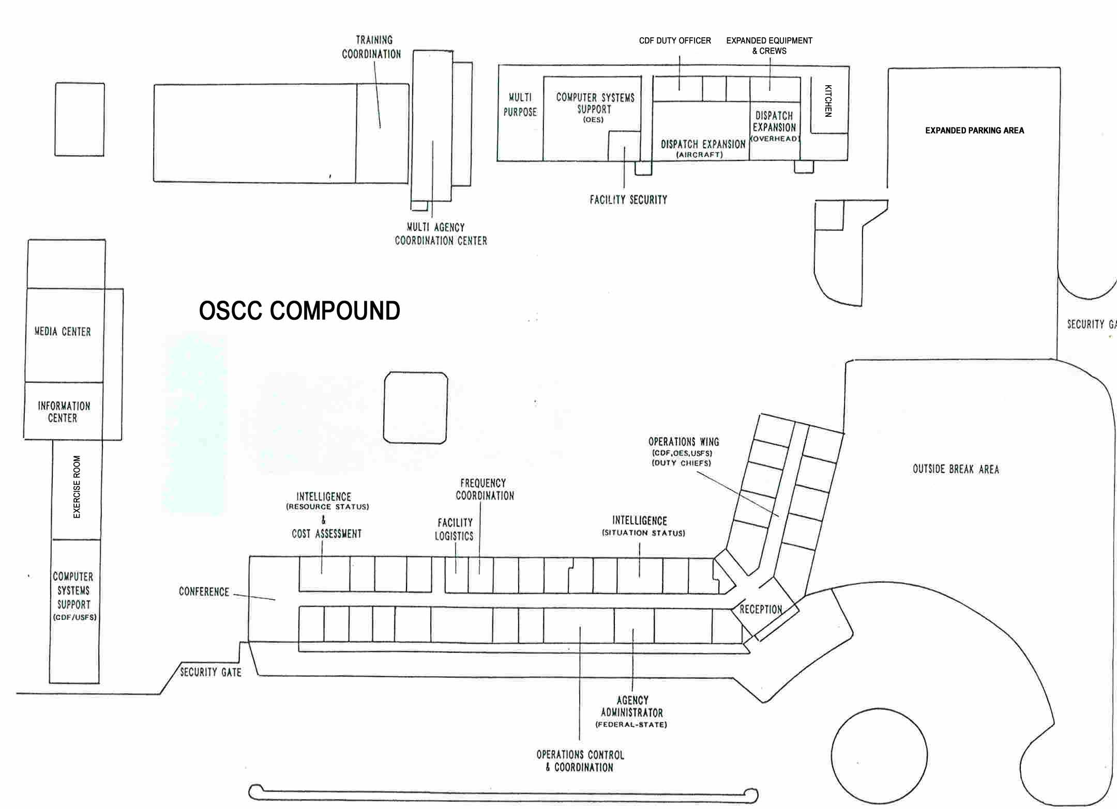

Expanded Dispatch Parking Lot

Predictive Services

N

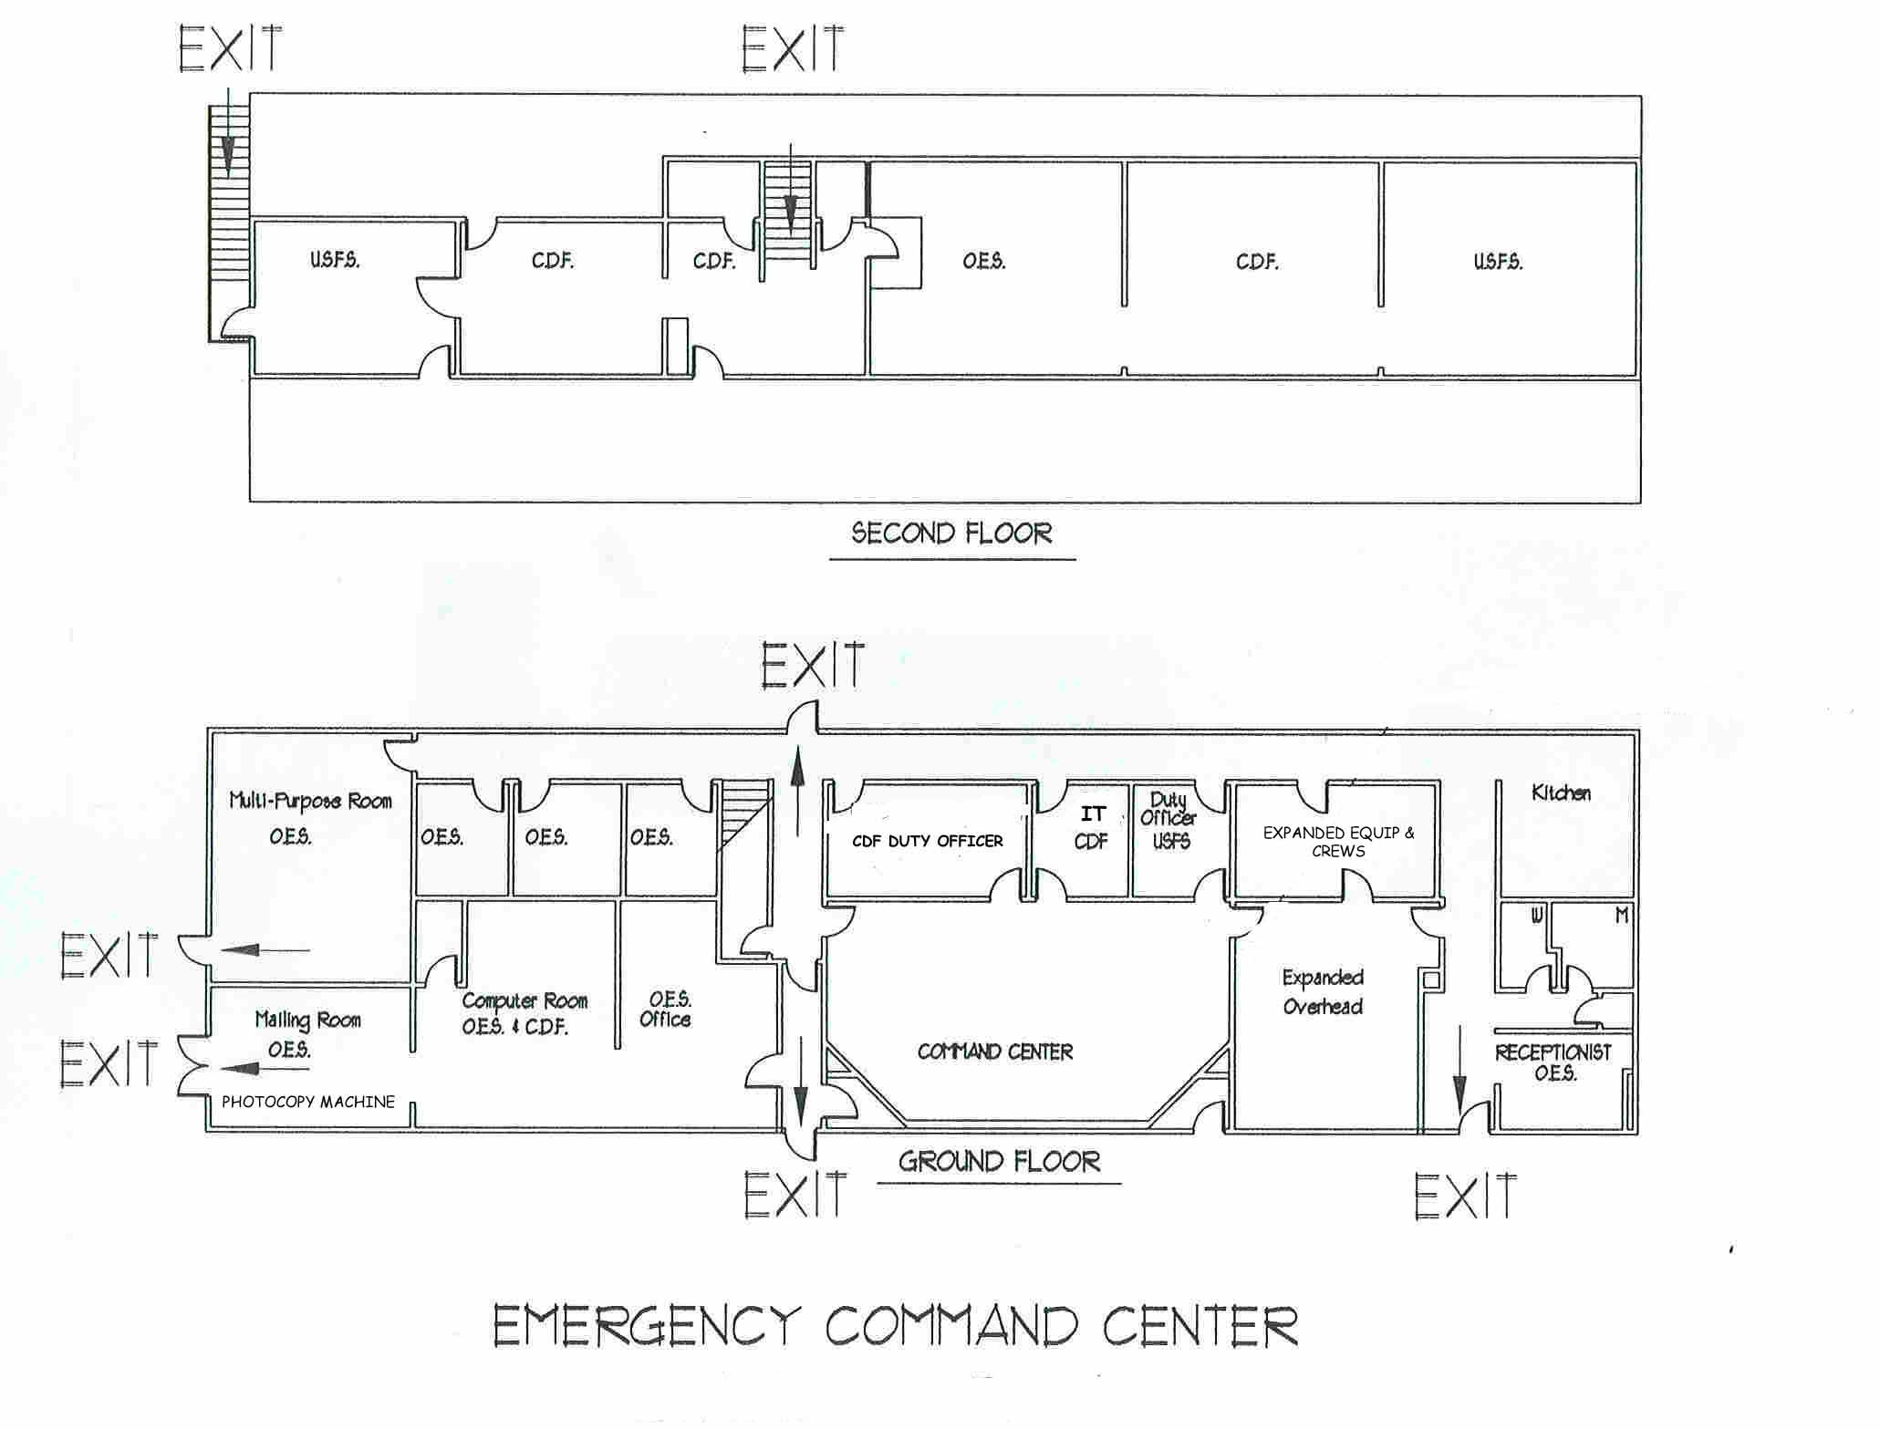

USFS Offices

Women’s Restroom

**Appendix B**

**OSCC Floor Plan**

Kitchen/ Break Room

Kitchen/ Break Room

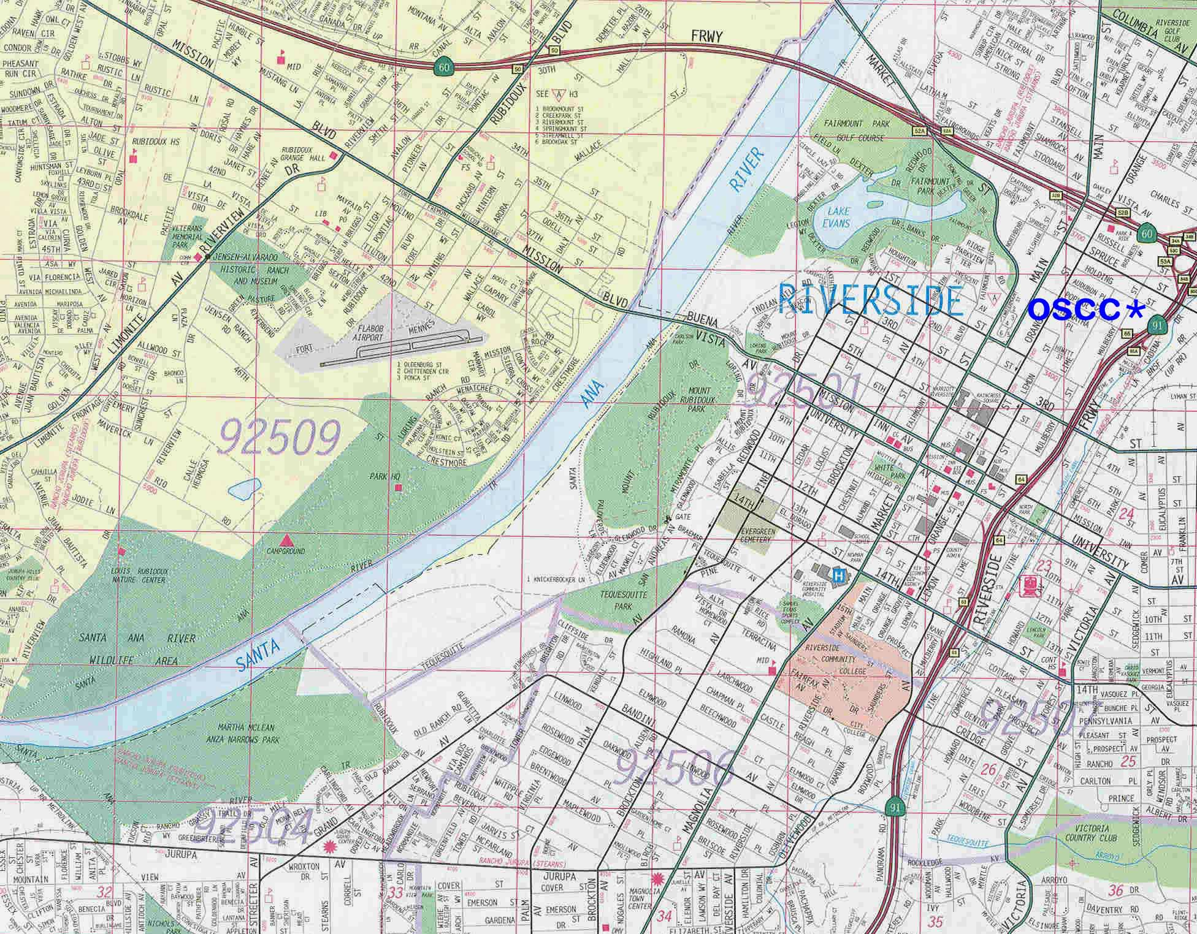

**Appendix B**

**Locality Map**

**Appendix B**

**Region 5 National Forests**

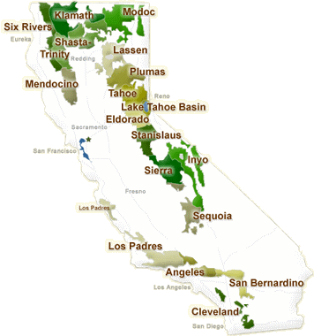

USDA Forest Service

R5 Forests

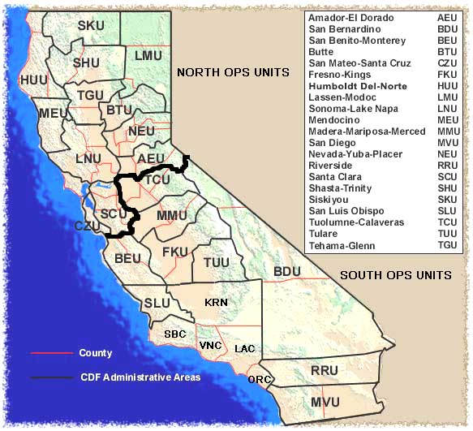

**Appendix B**

**CALFIRE Units and Contract Counties\***

* Contract Counties include:

KRN – Kern County SBC – Santa Barbara County

VNC – Ventura County ORC – Orange County

LAC – Los Angeles County

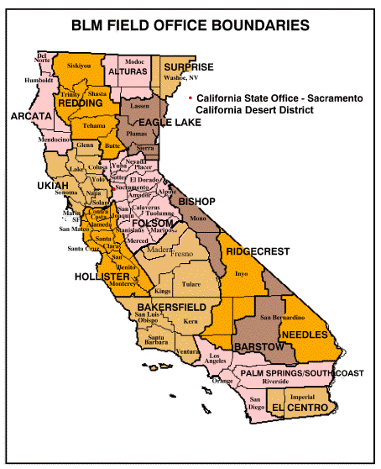

**Appendix B**

**BLM Field Offices in California**

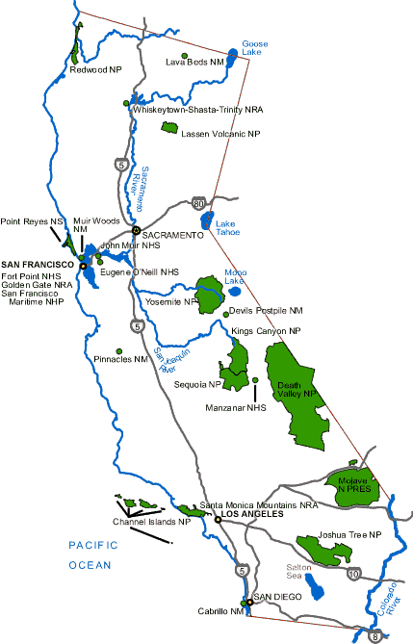

**Appendix B**

**National Park Service in California**

NATIONAL PARKS

NATIONAL PRESERVES

NATIONAL MONUMENTS

NATIONAL SEASHORES &

NATIONAL RECREATION AREAS



CALIFORNIA

OES REGIONS

**Appendix B**

**California Office of Emergency Services (OES)**

AGENCY 3-LETTER ROSS 4-LETTER CENTER NAME

**Appendix C**

**Agency Designations/ROSS Designators for OSCC**

**GACC OCC CA-OSCC SOUTH OPS**

**Southern Calif Geographic Cord Center**

**USFS – National Forests**

Angeles NF CA-ANF CA-ANCC Angeles Communication Center

San Bernardino NF CA-BDF CA-SBCC San Bernardino Interagency Communication

Center or “Federal Comm. Center”

Cleveland NF CA-CNF CA-MVIC Monte Vista Interagency Command Center

Inyo NF CA-INF CA-OVCC Owens Valley Interagency Communication Ctr.

Los Padres NF CA-LPF CA-LPCC Los Padres Communication Center

Sequoia NF CA-SQF CA-CCCC Central California Communication Center

Sierra NF CA-SNF CA-SICC Sierra Interagency Communication Center

Stanislaus NF CA-STF CA-STCC Stanislaus Communication Center

**BLM – Field Offices**

California Desert District CA-CDD CA-SBCC San Bernardino Interagency Communication

Center or “Federal Comm. Center”

Bakersfield District CA-CND CA-CCCC Central California Communication Center

Owens Valley District CA-OVD CA-OVCC Owens Valley Interagency Communication Ctr.

**NPS – National Parks, Preserves, etc.**

Channel Islands NP CA-CNP CA-LPFF Los Padres Communication Center

Death Valley NP CA-DVP CA-SBCC San Bernardino Interagency Communication Center or “Federal Comm. Center”

Joshua Tree NP CA-JTP CA-SBCC San Bernardino Interagency Communication

Center or “Federal Comm. Center”

Mojave National Preserve CA-MNP CA-SBCC San Bernardino Interagency Communication

Center or “Federal Comm. Center”

Santa Monica Mtn. NRA CA-SMP CA-ANCC Angeles Communication Center

Sequoia/Kings NP CA-KNP CA-SQCC Ash Mountain Fire Dispatch

Yosemite NP CA-YNP CA-YPCC Yosemite Emergency Communication Center

**Wildlife Refuges**

Southern California NWR CA-TNR CA-MVIC Monte Vista Interagency Command Center

San Luis NWR CA-LUR CA-SICC Sierra Interagency Communication Center

**Appendix C**

**Agency Designations/ROSS Designators for OSCC (cont.)**

**CALFIRE**

Tuolumne-Calaveras CA-TCU CA-TCCC Tuolumne-Calaveras Command Center

Madera-Mariposa CA-MMU CA-MMCC Madera-Mariposa-Merced Command Center

Monterey-San Benito CA-BEU CA-BECC San Benito-Monterey Command Center

Tulare CA-TUU CA-TUCC Tulare Unit Command Center

Fresno-Kings CA-FKU CA-FKCC Fresno-Kings Command Center

San Luis CA-SLU CA-SLCC San Luis Interagency Command Center

San Bernardino CA-BDU CA-BDCC San Bernardino Command Center

Riverside CA-RRU CA-RRCC Riverside Command Center

San Diego CA-MVU CA-MVIC Monte Vista Interagency Command Center

**Contract Counties**

Kern County CA-KRN CA-KRCC Kern County Command Center

Los Angeles County CA-LAC CA-LACC Los Angeles County Command Center

Orange County CA-ORC CA-ORCC Orange County Command Center

Santa Barbara County CA-SBC CA-SBDC Santa Barbara Dispatch Center

Ventura County CA-VNC CA-VNCC Ventura County Fire Communications Center

**OES**

OES, Sacramento CA-OESH California OES, Sacramento Headquarters

Region 1 CA-CR01 Region 1 California OES

Region 2 CA-CR02 Region 2 California OES

Region 4 CA-CR04 Region 4 California OES

Region 5 CA-CR05 Region 5 California OES

Region 6 CA-CR06 Region 6 California OES

**Appendix D OSCC**

Amenities

**Banks**

1. **Bank of America – 1680 University Ave, 909-686-2590**
2. **Citibank – 1651 University Ave,**
3. **Union Bank of California – 9103 Mission Bl, 951-360-5680**
4. **Wells Fargo – 3750 University Ave, 951-782-2622**
5. **Provident – 4001 Main Street, 951-682-3272**

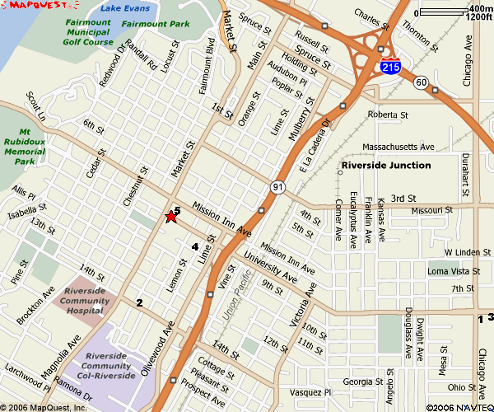

**Appendix D OSCC**

Amenities

**Groceries**

1. **Food 4 Less - 3900 Chicago Ave, 951-369-9434**
2. **Ralph’s – 6155 Magnolia Ave, 951-274-9543**
3. **Stater Brothers – 2995 Iowa Ave, 951-686-0132**
4. **Vons – 3520 Riverside Ave, 951-342-7924**
5. **Trader Joe’s – 6225 Riverside Ave, 951`-682-4684**

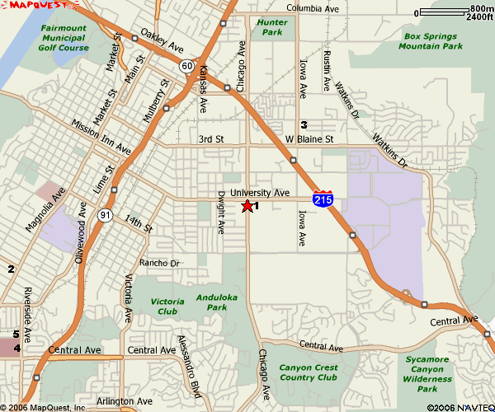

**Appendix D OSCC**

Amenities

**Laundry**

**OSCC has a laundry area which is first come, first use. You must provide your own soap and supplies for the machines.**

1. **AAA Launderland – 3375 Iowa Ave, 951-781-4005**

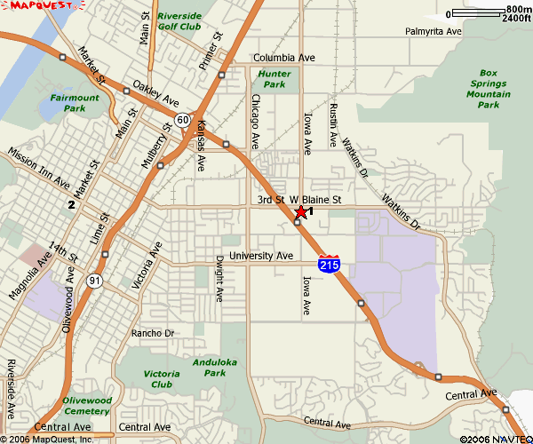

**Appendix D OSCC**

Amenities

**Lodging**

1. **Marriott – 3400 Market St, 951-784-8000**
2. **Mission Inn – 3649 Market St, 951-784-0300**
3. **Holiday Inn Express Colton – 2830 Iowa Ave, 951-788-9950**

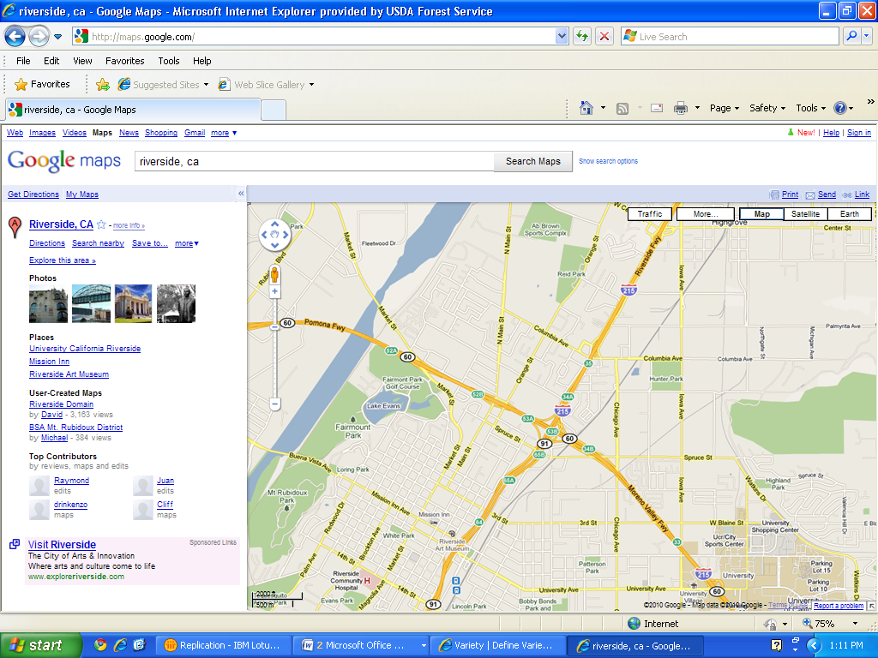

**3**

**1**

**2**

**Appendix D**

Amenities

**Lodging - San Bernardino**

1. **San Bernardino Residence Inn, 1040 E Harriman Pl, San Bernardino, CA (909) 382-4564**
2. **Fairfield Inn and Suites, 1041 E. Harriman Place, San Bernardino, CA (909) 382-4560 () ‎**
3. **Hilton San Bernardino, 285 East Hospitality Lane, San Bernardino, CA (909) 889-0133 ()**
4. **La Quinta Inn San Bernardino, 205 East Hospitality Ln, San Bernardino, CA (909) 888-7571 ()**
5. **Hilton Garden Inn, 1755 S Waterman Ave, San Bernardino, CA (909) 806-4040 () ‎**

4

3

1

5

2

TO OSCC:

215 South to 60 West then Exit on Main St.

‎ 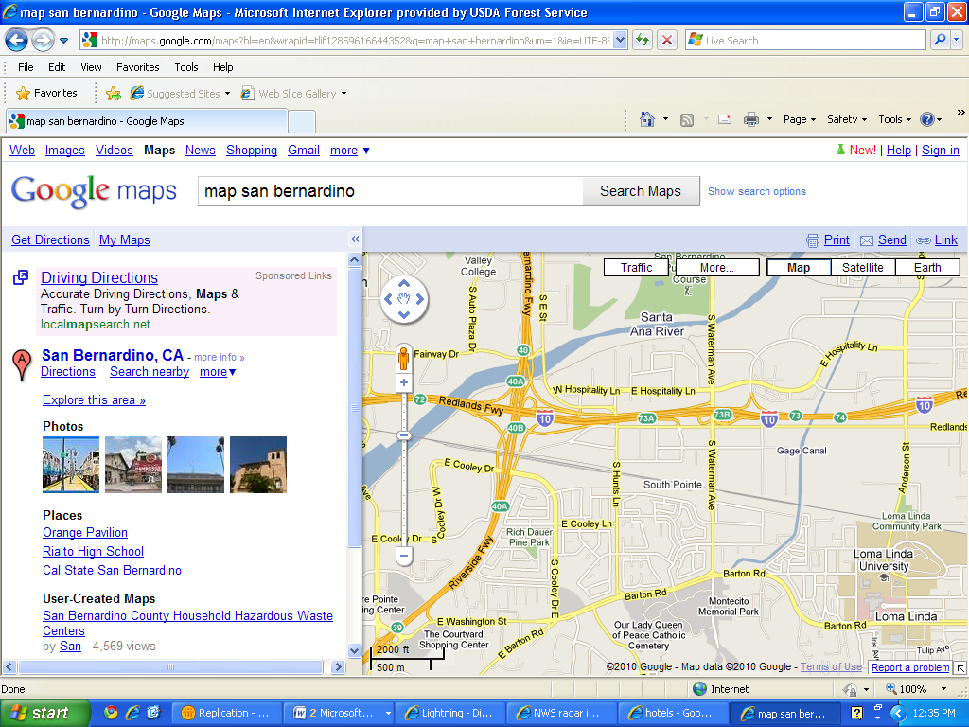

**Appendix D**

Amenities

**Restaurants**

The choices are numerous and ever changing. Please make sure of the Menu Book, local knowledge and searches of the internet to find something you like. Ask regular OSCC staff for help as needed.

**Appendix E**

OSCC Detailer Survey

The purpose of this survey is to identify ways to help OSCC improve our operational and customer service needs. Your constructive feedback is very important to help us with our continuous improvement process.

OSCC visitors and detailers are asked to complete the following survey; all sensitive comments will be kept confidential. Please feel free to use the back of the form if additional space is needed.

1. What recommendations or changes would you suggest to our office procedures to help us streamline operations?
2. Did OSCC provide an adequate orientation and work materials? What information was not provided that would be beneficial to other visitors in the future?
3. Was the OSCC staff helpful during your detail?
4. Were the facilities adequate? If not, what improvements would you suggest?
5. What did you enjoy most about your visit to OSCC?

Please submit completed form to Beth Mason ([bmason02@fs.fed.us](mailto:bmason02@fs.fed.us))

Mail: 2524 Mulberry St., Riverside, CA 92501

Thank you for participating with our survey!